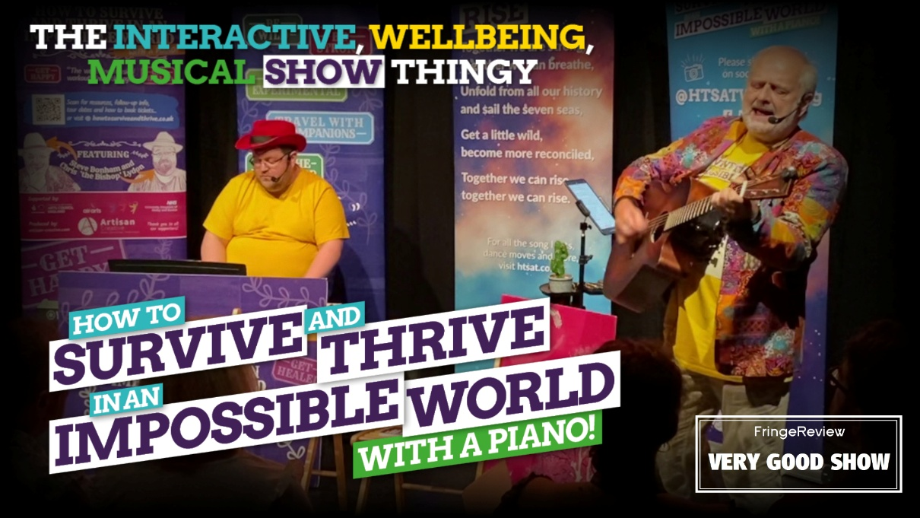

**PRESS RELEASE**

**Reimagined. Regenerated. Ridiculously Relevant.**

***"How to Survive and Thrive in an Impossible World - with a piano!"* comes to Brighton Fringe for four shows only!**

The world still feels impossible – so what better time to return with a show that helps you thrive in it?

This May, Steve Bonham and Christopher ‘the Bishop’ Lydon bring their hit show *“How to Survive and Thrive in an Impossible World - with a piano!”* to Brighton Fringe – freshly reworked, playfully provocative, and more timely than ever.

Described as a mix of interactive storytelling, off-beat psychology, rebellious wisdom and original music, this “interactive, wellbeing, musical show thingy” started life as a companion to Steve’s book of the same name, and has since grown into a much-loved live experience. The pilot version was supported by Arts Council England and tested by frontline NHS staff. The show has been celebrated at the Edinburgh Fringe, and now regenerated for 2025.

**What’s new? Quite a lot.**

Steve’s award-winning background in psychology meets a deep love of storytelling, creating a show that blends big ideas with humour, soul, and a touch of mischief. Along the way, you'll meet concepts like the Mindful Gap, the Mischief Zone, Natural Resilience, and the liberating notion of psychological rewilding – all with a soundtrack of original songs, performed live by Steve with ‘the Bishop’ at the piano.

Whether you’re burned out, buzzing with questions, or just up for something different, this is a performance to refresh your spirit and tickle your brain.

Catch the show at Brighton Fringe (four performances only!) and be among the first to experience the regenerated version before it hits the road.

**How to Survive and Thrive in an Impossible World - with a piano!**

**Rotunda Theatre: Squeak**@ Regency Square, BN1 2FG  
(opposite the i360)

23 May, 5.15pm  
24 – 26 May, 3.45pm

£10 full / £8 concession

Duration: 60 mins. Suitable for 12+.  
Mild occasional swearing; gentle optional audience interaction.

Tickets from [htsat.co.uk](https://www.htsat.co.uk)

**- ENDS -**

**Background**

**Artisan Creative**

Artisan Creative develops distinctive books, recordings and performances, including new theatre pieces, gigs, concerts and festivals, all celebrating the 'extraordinary stories of ordinary folk', rooted in the values of craft, authenticity, inspiration and a love of the raw materials used. Based on over 30 years of experience of working with professional and non-professional collaborators, they have delivered everything from large-scale community projects to intimate solo performances.

[artisan-creative.com](https://www.artisan-creative.com/)

**Contacts and further information**

Steve Bonham [steve@artisan-creative.com](mailto:steve@artisan-creative.com) 07711 788248

Chris Lydon [chris@artian-creative.com](mailto:chris@artian-creative.com) 07816 996769

More about **How to Survive and Thrive in an Impossible World – with a piano!** at [htsat.co.uk](https://www.htsat.co.uk/)

More about **Artisan Creative** at [artisan-creative.com](https://www.artisan-creative.com/)

Photographs, logos etc. available from [htsat.co.uk/about/press](https://www.htsat.co.uk/about/press)